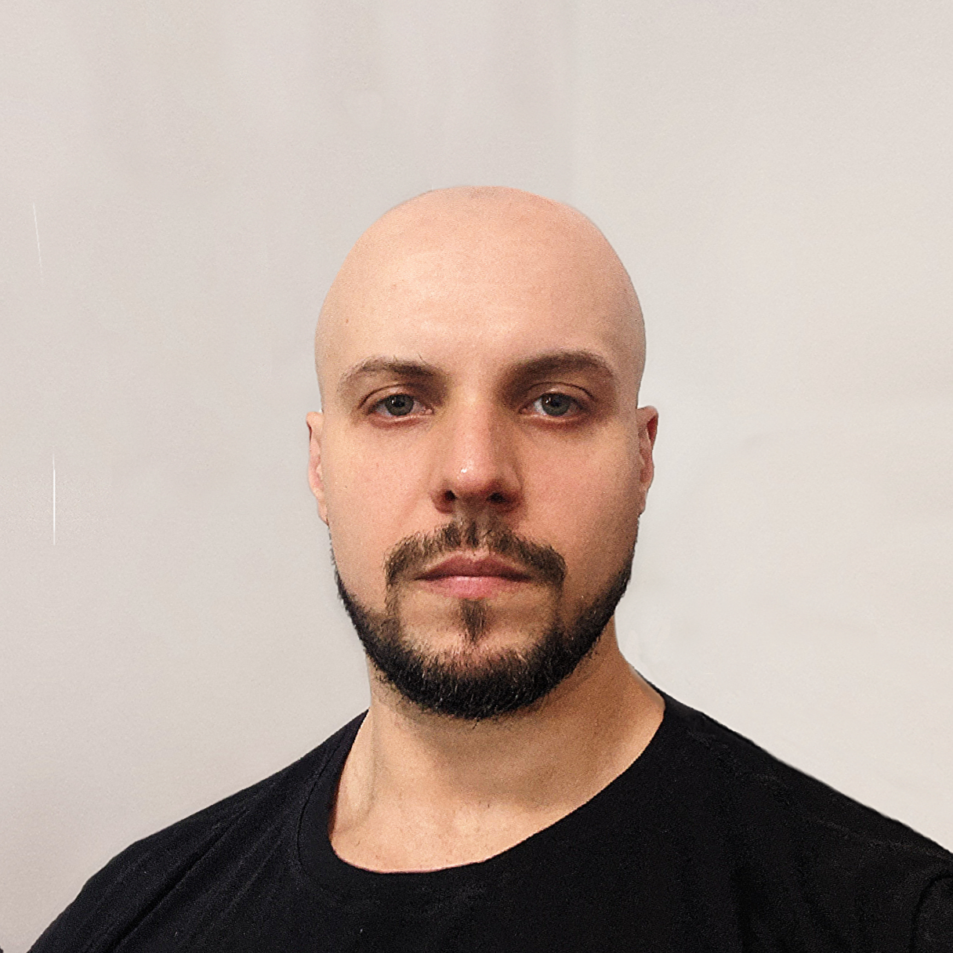

Elton Fonseca de Mattos

Dynamics 365/Power Platform Developer
 elton.mattos@outlook.com ▪  (11) 97270-8392 ▪  elton-mattos

eltonmattos.github.io ▪eltonmattos

 R. Rui de Morais Apocalipse - Jd. do Tiro - São Paulo - SP

About Me
◾ Experience in projects involving customization, development of extensions and integrations, deployment, training, and support for Dynamics 365/Dataverse and Power Platform.
◾ 10 years of experience developing for Microsoft Power Platform and Dynamics (CRM 2011 to 365) using C# and JavaScript programming languages.
◾ Certified professional: MS Power Platform Solution Architect Expert, MCSA: Dynamics 365, and MCSE: Business Applications.

Professional experience

Software Engineer

NTT Data | São Paulo, SP (Remote) Jun/2022 – Jul/2024
Development and maintenance of extensions (Plugins, Custom Workflows, Scripts, Power Automate, Integrations) using C# and JavaScript programming languages, customization of Dynamics 365 environment, and training teams for developing Extensions for Dynamics 365/Dataverse.

Dynamics 365/Power Platform Developer

Smart Consulting | São Paulo, SP (Remote) May/2021 - Jun/2022

Dynamics 365/Power Platform Developer

Best.Projects | São Paulo, SP (Remote) Jul/2020 - May/2021

Dynamics 365/Power Platform Developer - Smart Consulting | São Paulo, SP Mar/2017 - Apr/2020

Dynamics 365/Power Platform Developer - I4D IT Solutions | São Paulo, SP (Híbrido) Aug/2015 - Dec/2016

Web Developer (ASP/XHTML/JavaScript) - Paicon Technologies | São Paulo, SP Feb/2015 - Jul/2015

Dynamics CRM Developer - Smart Consulting | São Paulo, SP Mar/2013 - Dec/2014

Database/DBM Analyst (MS SQL Server) - Logystem Logística e Sistemas | São Paulo, SP Oct/2010 - Dec/2012

Education

Postgraduate Specialization in .NET System Architecture with Azure

FIAP Mar/2024 - Mar/2025

Bachelor's in Computer Science

UNIP – Universidade Paulista Jul/2009 - Jun/2013


Certifications
Microsoft Certified: Power Platform Functional Consultant Associate Dez/2023
- Exam PL-200: Microsoft Power Platform Functional Consultant

Microsoft Certified: Dynamics 365 Customer Service Functional Consultant Associate Dez/2023
- Exam MB-230: Microsoft Dynamics 365 Customer Service Functional Consultant

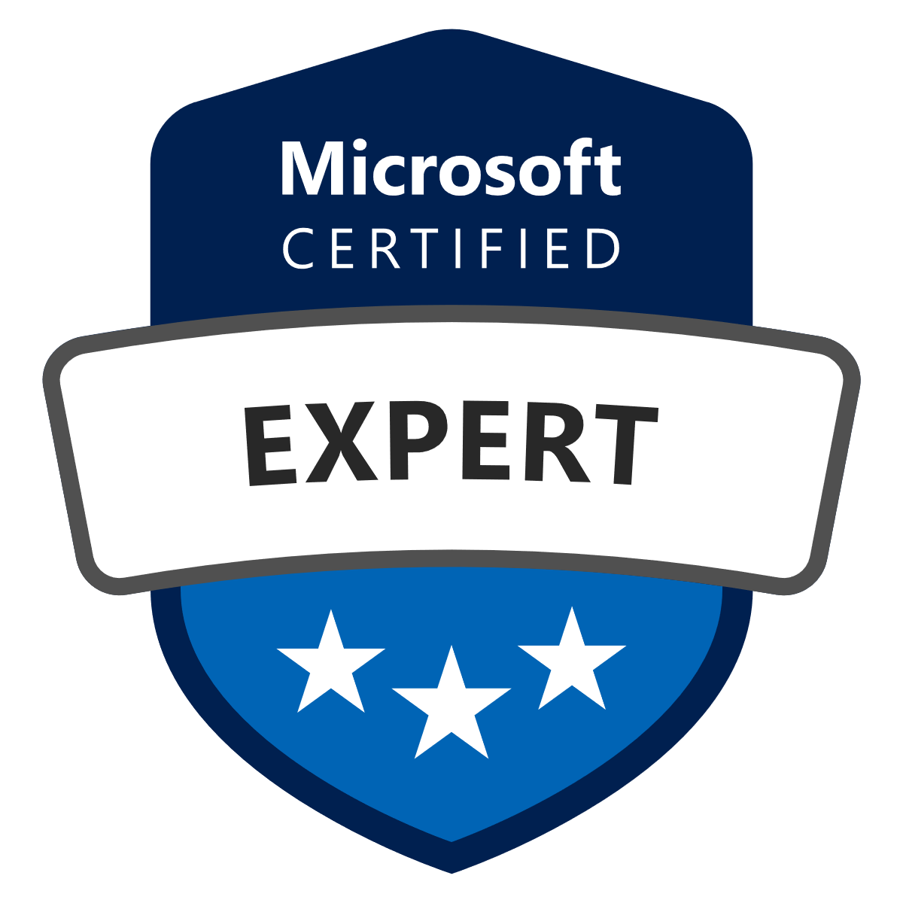
Microsoft Certified: Power Platform Solution Architect Expert Nov/2023
- Exam PL-600: Microsoft Power Platform Solution Architect

Microsoft Certified: Power Platform Developer Associate Set/2023
- Exam PL-400: Microsoft Power Platform Developer
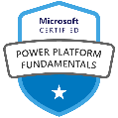
Microsoft Certified: Power Platform Fundamentals Mar/2023
- Exam PL-900: Power Platform Fundamentals

Microsoft® Certified Solutions Expert: Business Applications Jun/2019
Microsoft® Certified Solutions Associate: Dynamics 365 Mai/2018
Microsoft Specialist: Microsoft Dynamics CRM 2016 Customization and Configuration Mai/2017
Microsoft Dynamics Customization and Configuration in CRM 2013 Set/2014

Technical Skills
- Power Platform:
  - Customization of Dataverse/Dynamics 365, Development of Extensions for Dataverse, Plugins, Custom Workflows, Actions/Custom API, Integrations via CRM SDK/CRM WEB API, JavaScript for Model-Driven Forms
  - Power Automate
- C# Programming Language
- Website Development using XHTML, CSS, ASP, JavaScript, JQuery, Bootstrap
- MS SQL Server Database
- Graphic Design Programs: Photoshop, Corel Draw

Other activities
Computer Science Instructor (2007-2013)
- Senac - Instructor (Excel) Sep/2013 - Dec/2013
- Eurodata - Instructor (Office/Hardware and Networking) Aug/2010 - Dec/2012
- Data Byte - Instructor (Office/Hardware and Networking) Apr/2008 - Jul/2009
- Infopro Cursos & Soluções – Instructor (Hardware and Networking)/Class Monitor Oct/2007 - Mar/2010
Computer Repair and Maintenance since 2006
Development and Administration of Personal Websites using HTML and CSS (2003-2007)

